Movie Success Prediction System using Python

- Background/ Problem Statement

Today, the trouble is that the more things change, the more they stay in the same horizons. Now, filmmaking in India is a multimillion-dollar industry employing over 6 million workers and reaching millions of people worldwide. In 2008 industry was valued at 107.1 billion rupees.
With such a fortune and the employment of so many people at stake every Friday, it will be of immense interest to producers to know the probability of success or failure of a movie. Nevertheless, producers and distributors of new movies need to forecast box-office results in an attempt to reduce the uncertainty in the motion picture.
An attempt is made to predict the past as well as the future of a movie for the purpose of business certainty or simply a theoretical condition in which decision making [the success of the movie] is without risk because the decision maker [movie makers and stake holders] has all the information about the exact outcome of the decision before he or she makes the decision [release of the movie].

- Working of the Project

One needs to know then the minimum sum of money he/she can accept to forgo the opportunity to participate in an event [make/distribute etc. movie] for which the outcome [success or failure of the movie], and therefore his or her receipt of a reward, is uncertain [the success of the movie].
For developing a model that can help to predict whether the movie flop, we propose that we need to create the historical data set relating to parameters that influence movie success and develop an algorithm to assign weights and develop a mathematical model to automate and predict movie success and finally evaluate the performance of the algorithm to know how good or bad our movie prediction system is.

The front-end involves Html, CSS, and JavaScript and the back-end involves Python. The framework used is Django and the database is MySQL. Here will use logistic regression for training and detection.

- Advantages

- It is easy to maintain.
- It is user-friendly.
- This application helps to find out the review of the new movie.
- Users can easily decide whether to book tickets in advance or not.
- Prediction of marketing budget.

- System Description
The system comprises 2 major modules with their sub-modules as follows:

- ADMIN:

- Login: Admin can log in using username and password.
- Training Data: Admin will add training data for training the model.

- USER:

- Sign up: User has to register their account with their basic details such as their name, contact no., email, password, username, user image, and age.
- Sign in: The user has to log in using a username and password.
- Prediction: The user will fill in data like cast names (actor and actress), movie name, movie budget, and producer name and will get success prediction as a flop, hit or superhit.

- Project Life Cycle

The waterfall model is a classical model used in the system development life cycle to create a system with a linear and sequential approach. It is termed a waterfall because the model develops systematically from one phase to another in a downward fashion. The waterfall approach does not define the process to go back to the previous phase to handle changes in requirements. The waterfall approach is the earliest approach that was used for software development.

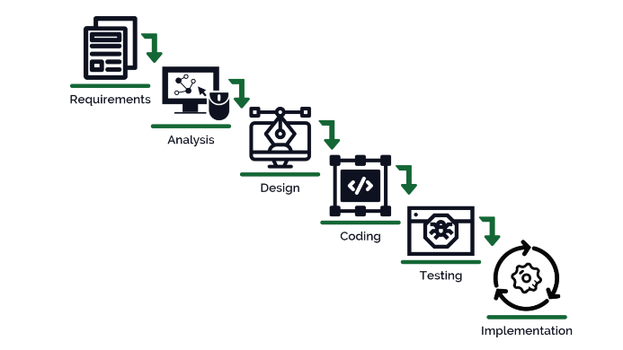

- System Requirements

- Hardware Requirement

- Laptop or PC
- Windows 7 or higher
- I3 processor system or higher
- 4 GB RAM or higher
- 100 GB ROM or higher

- Software Requirement

- Laptop or PC
- Python
- Sublime Text Editor
- XAMP Server

- Limitation/Disadvantages
- Users can predict the success of the movie before its release of the movie.
- It will predict if certain data exists in the database.

- Application – This application helps to predict movie success rates based on past data.

- Reference
- https://www.researchgate.net/publication/349585795_Movie_Success_and_Rating_Prediction_Using_Data_Mining_Algorithms
- https://www.diva-portal.org/smash/get/diva2:1106715/FULLTEXT01.pdf

